**Anatolie Jentimir**

[**2024FA CSC-284-WB**](https://online.bhcc.edu/course/view.php?id=39162#section-11)

**11/17/2024**

**Topic 8 Reading Assignment**

*QtTcpSocket*

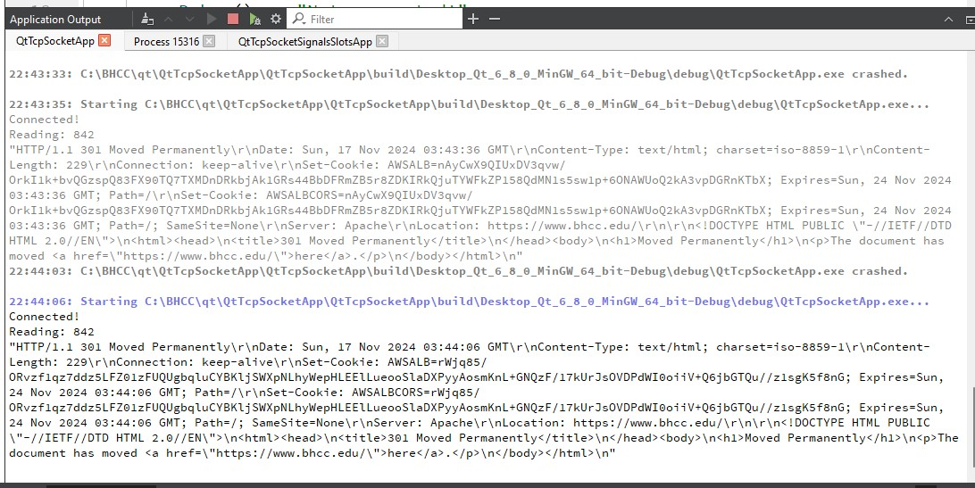

*QtTcpSocket application to make it the Signals and Slots application:*

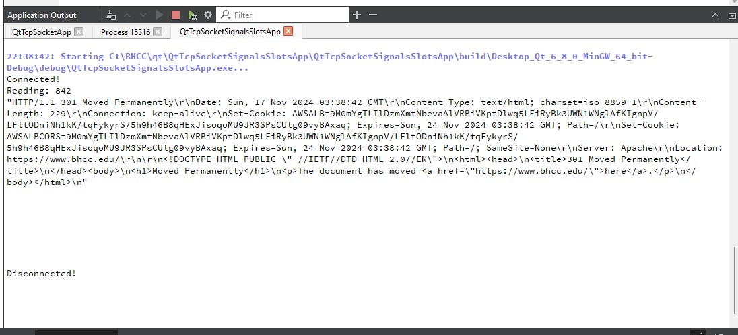

*QtTcpSocket application with Signals and Slots so that doConnect takes a string as an inputparameter.*

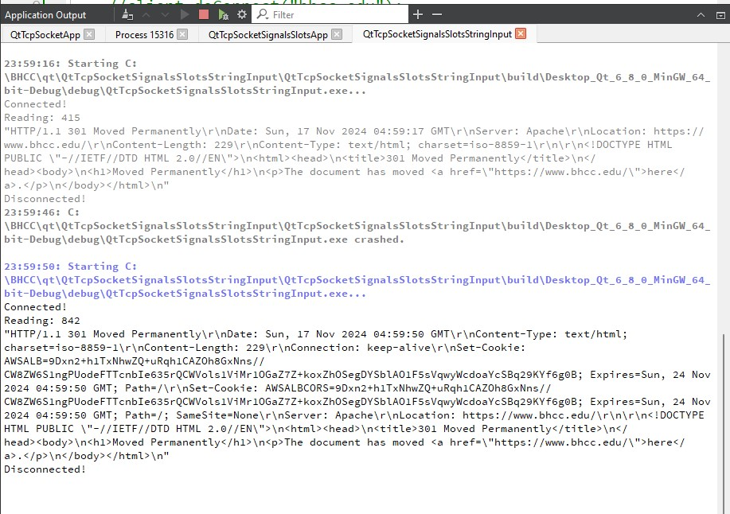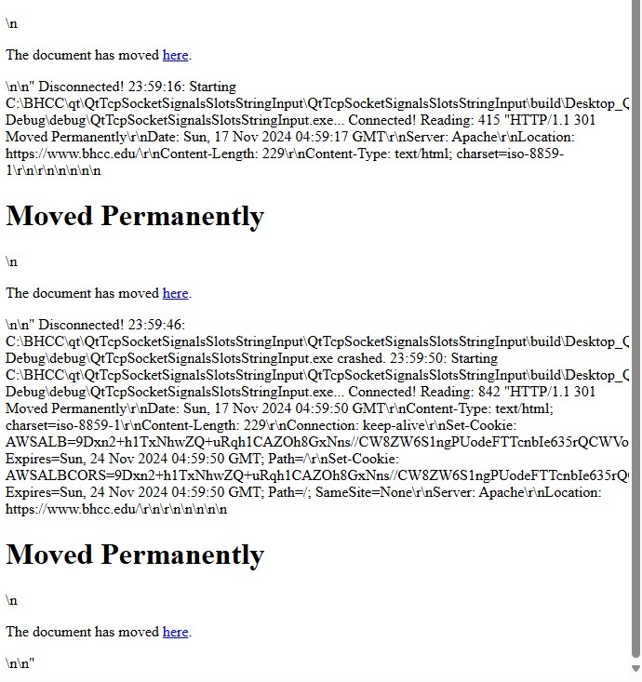

**What is the purpose of TCP?**

TCP, or Transmission Control Protocol, is a protocol that outlines how to initiate and maintain a network conversation, allowing application programs to exchange data. It works in conjunction with the Internet Protocol (IP), which specifies how computers send data packets to each other.

**How does TCP differ from FTP?**

TCP is a transport layer protocol that ensures the reliable, ordered, and error-checked delivery of data streams between applications. On the other hand, FTP (File Transfer Protocol) is an application layer protocol that leverages TCP to transfer files between computers on a network.

**When might one use TCP?**

TCP is employed when dependable communication is essential. This includes scenarios such as web browsing, email, file transfers, and any application where data integrity and order are paramount.